Cit Pecyn Ymarfer a Gweithgareddau (De) Uned 24
Practice and Activity Pack (South Wales) Unit 24

A. Sut dych chi’n mynd ar eich gwyliau?

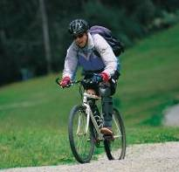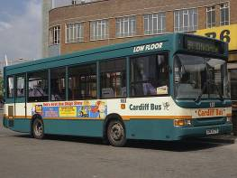

ar y beic ____ __ ________ ____ __ ______ ____ ________

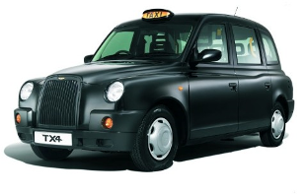
________ ______ ________ ________ ______________
__________ ____________

B. Llenwch y bylchau

__ ______ ______ _______ ______ ____ wreiddiol? ____ _____ ______ __ Abertawe.
______ ______ Gareth ____ ________? I __________________. (Llandrindod)

C. Treigladau!

Dw i’n mynd i...
__________________________ (Pontarddulais) ________________ (Tregaron)
__________ (Conwy) ________________________ (Bro Morgannwg)
________________ (Dyfnaint) ______________ (Gwynedd)
______________________ (Meirionnydd) _______________ ______ (Rhaeadr Gwy)

Ch. Atebwch

O ble dych chi’n dod yn wreiddiol? _________________________________________________
Ble dych chi’n mynd ar eich gwyliau nesa? _________________________________________________

D. Ysgrifennwch am eich gwyliau nesa!

I ble dych chi’n mynd, a sut? Pwy sy’n mynd gyda chi?
Ble dych chi’n mynd i aros? Beth dych chi’n mynd i wneud?
____________________________________________________________________________________
____________________________________________________________________________________
____________________________________________________________________________________
____________________________________________________________________________________

Uned 24 Gweithgaredd

Creu stori Creating a story
- There are four categories of pictures on the next page: people, modes of travel, destinations, and activities. Cut them out and spread them out face up on a table top
- Use the pictures to make up a holiday for the Edwards family. Say also what country/town they are going to, and add as much other detail as you can think of (time of day, day of the week, what they wear/eat, etc.)
- Your child may prefer to use his/her toy characters instead of the Edwards family pictures, and any other props – the more, the merrier (as long as they help tidy up afterwards!)
- If your child is old enough, and enjoys such an activity, you might want to write a short story together: Wyt ti eisiau ysgrifennu stori?

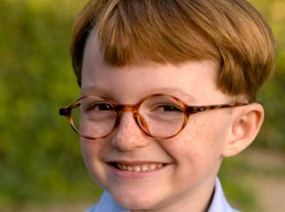  Siôn | 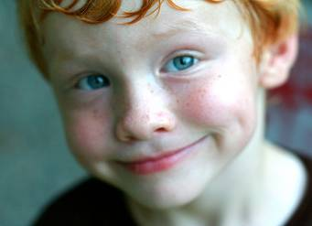Huw | 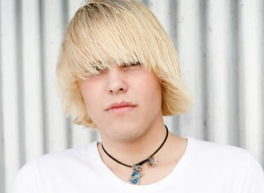  Marc |   Sara a Nia | Mr a Mrs Edwards | 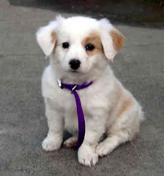 Duncan
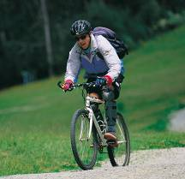 |  |  |  |  | 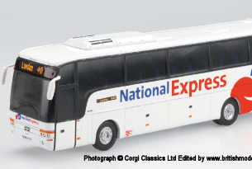
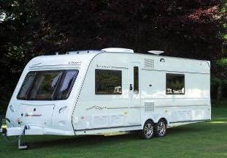 | 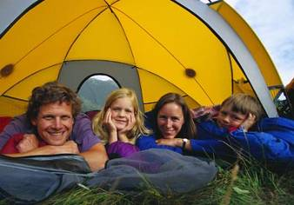 |  | 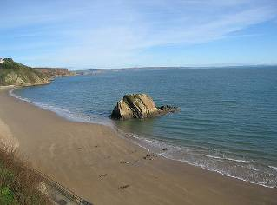 | 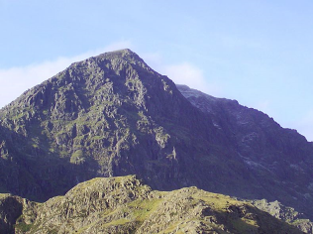 | 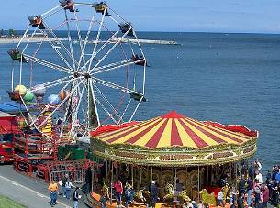
 |  |  | 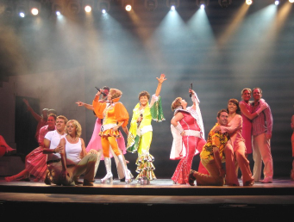 | 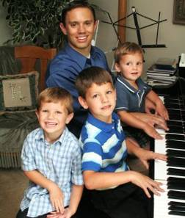 | 

